**Chapter 1**

**Introduction**

The advancements in technology, particularly in the fields of IoT (Internet of Things) and automation, have opened up new opportunities to improve the management of space and resources in various environments. Traditional methods of monitoring room occupancy, while essential, often fail to provide real-time updates and accurate data, which are crucial for maintaining safety and efficiency.

The IoT-Based In and Out Counting System project aims to bridge this gap by integrating modern technologies such as IoT, sensors, and automated counting mechanisms into a single solution. By offering automated counting of individuals entering and exiting a room, the system provides accurate real-time data on occupancy levels. The inclusion of visual indicators, such as blinking lights and a digital display, ensures reliability, while IoT connectivity enables advanced functionalities such as remote monitoring and data logging.

This chapter provides an overview of the data collection process, the chosen SDLC model for development, and a project timeline using a Gantt Chart to ensure a structured and efficient approach to implementation.

* 1. **Data Collection**

The data collection process is vital to the successful implementation of the IoT-Based In and Out Counting System. It involves several key steps to ensure that the system meets user requirements, functions accurately, and performs reliably in various environments. The data collection process includes:

**User Requirements Gathering:**

* Conducting interviews and surveys with potential users (e.g., hospital staff, event organizers, office managers) to understand their specific needs, preferences, and expectations.
* Identifying key use cases and scenarios where the system will be deployed, ensuring that it aligns with the intended purpose and user needs.

**Environmental Analysis:**

* Assessing the physical layout of rooms and entry/exit points to determine optimal sensor placement and coverage.
* Conducting site visits and measurements to gather data on room dimensions, potential obstacles, and environmental factors that may affect sensor performance.
* Evaluating lighting conditions, as well as potential sources of interference (e.g., electronic devices, physical barriers), to ensure accurate sensor detection.

**Performance Testing:**

* Conducting trials and simulations to evaluate sensor accuracy and system responsiveness in various conditions.
* Testing the system with different numbers of people and varying entry/exit speeds to ensure reliable performance under diverse scenarios.
* Analyzing data from test runs to identify potential issues and areas for improvement, making necessary adjustments to optimize system accuracy and reliability.

**Data Validation:**

* Comparing collected data with manual counts to validate the accuracy of the system.
* Implementing feedback mechanisms to gather user input and further refine the system based on real-world usage and observations.
  1. **SDLC Model**

**AGILE MODEL**

• The meaning of Agile is swift or versatile.

• It refers to a software development approach based on iterative development.

• Agile methods break tasks into smaller iterations, or parts which do not directly involve long term planning.

• Agile SDLC model is a combination of iterative and incremental process models with focus on process adaptability and customer satisfaction by rapid delivery of working software products.

• Iterative approach is taken and working software build is delivered after each iteration. Each build is incremental in terms of features; the final build holds all the features required by the customer**.**

**Phases of Agile Model:**

Following are the phases in the Agile model are as follows:

1. Requirements gathering

2. Design the requirements

3. Construction/ iteration

4. Testing/ Quality assurance

5. Deployment

6. Feedback

**Key Features of Agile Model:**

* Iterative and Incremental Approach:

The project is divided into small iterations called sprints, each lasting 1-4 weeks.Every sprint delivers a working prototype or functional feature of the project.

* Customer Collaboration:

Continuous feedback from stakeholders is incorporated at every sprint, ensuring that the final product aligns with user expectations.

* Flexibility:

Agile allows modifications in requirements and priorities even during later stages of development.

* Faster Delivery:

Working features are delivered at the end of each sprint, ensuring quick and incremental delivery of the project.

**Advantages (Pros) of Agile Method:**

**•** Frequent Delivery

• Face-to-Face Communication with clients.

• Efficient design and fulfils the business requirement.

• Anytime changes are acceptable.

• It reduces total development time.

**Disadvantages (Cons) of Agile Model:**

**•** Due to the shortage of formal documents, it creates confusion and crucial decisions taken throughout various phases can be misinterpreted at any time by different team members.

• Due to the lack of proper documentation, once the project completes and the developers allotted to another project, maintenance of the finished project can become a difficulty

The Agile Development model is chosen for this project due to its iterative and incremental approach, which allows for continuous feedback and improvements. This model consists of the following phases:

1. Planning:
   * Defining project scope, objectives, and timelines.
   * Identifying key stakeholders and establishing communication channels.
   * Developing a project plan that outlines tasks, resources, and milestones.
2. Design:
   * Creating system architecture and detailed design specifications.
   * Designing sensor placement, wiring diagrams, and overall system layout.
   * Developing user interface designs for the LED display and control panel.
3. Development:
   * Writing and testing code for sensors, display, and overall system integration.
   * Developing firmware for the Arduino board to manage sensor inputs and display outputs.
   * Implementing IoT connectivity features for remote monitoring and data logging.
4. Testing:
   * Conducting unit tests to verify the functionality of individual components.
   * Performing integration tests to ensure that all components work seamlessly together.
   * Running user acceptance tests to validate the system's performance in real-world scenarios.
   * Identifying and resolving any bugs or issues detected during testing.
5. Deployment:
   * Installing the system in the target environment and conducting initial setup.
   * Providing user training and documentation to ensure effective use of the system.
   * Monitoring the system's performance during the initial deployment phase and making any necessary adjustments.
6. Maintenance:
   * Offering ongoing support and troubleshooting to address any issues that arise.
   * Gathering user feedback to identify areas for improvement and feature enhancements.
   * Implementing software updates and hardware upgrades as needed to maintain optimal system performance.

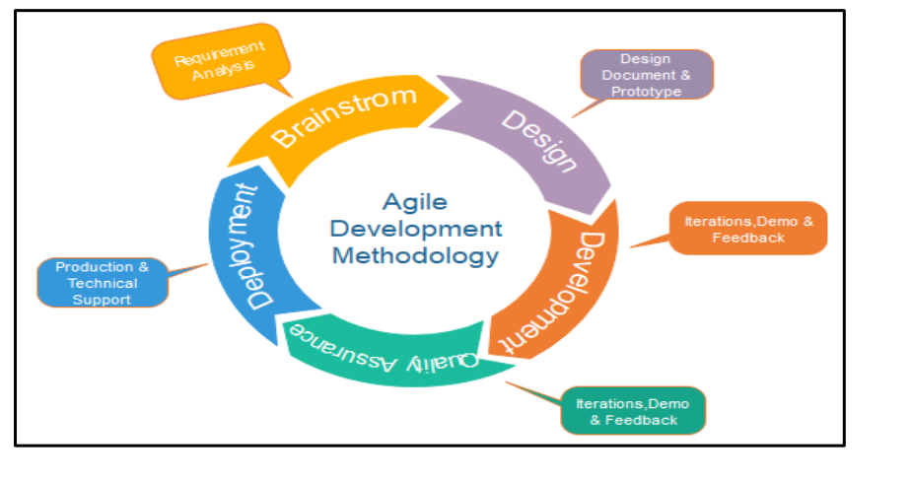

* 1. **Gantt Chart**

A Gantt Chart is used to visualize the project timeline, outlining key milestones and deadlines to ensure a structured and efficient approach. The timeline includes:

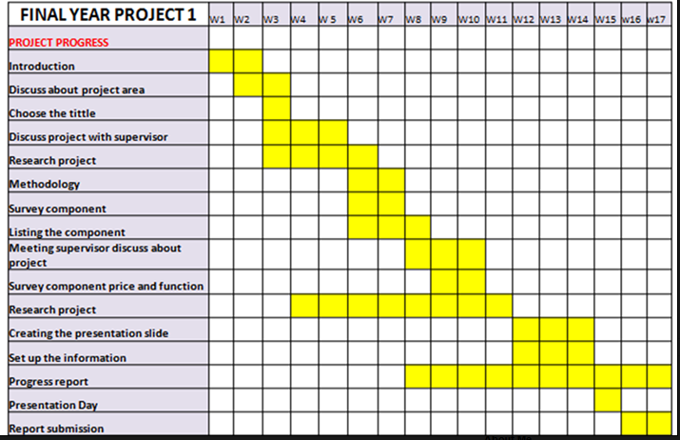

**Chapter 2**

**SRS of IoT-Based In and Out Counting System**

The SRS is a specification for a specific software product, program, or set of applications that perform particular functions in a specific environment. It serves several goals depending on who is writing it. First, the SRS could be written by the client of a system. Second, the SRS could be written by a developer of the system. The two methods create entirely various situations and establish different purposes for the document altogether. The first case, SRS, is used to define the needs and expectation of the users. The second case, SRS, is written for various purposes and serves as a contract document between customer and developer.

**1. Introduction**

The IoT-Based In and Out Counting System is a smart and efficient solution designed to count and monitor the number of people entering and exiting a room or area. Using Internetof Things (IoT) technology, sensors, and automated counting mechanisms, the system provides real-time data on room occupancy. This innovative system is ideal for environments such as hospitals, offices, auditoriums, and libraries, where accurate monitoring of occupancy is essential for safety, resource management, and operational efficiency.

The system is built to automate occupancy tracking processes with minimal human intervention, leveraging state-of-the-art technology like IoT connectivity for remote monitoring and data storage. With key features such as real-time counting, visual feedback, and cloud-based data logging, this system aims to revolutionize traditional approaches to room occupancy management.

**1.1 Purpose**

The purpose of this document is to define the functional and non-functional requirements for the IoT-Based In and Out Counting System. This system is designed to accurately track and display the number of individuals entering and exiting a room, providing real-time updates on occupancy levels. The system integrates IoT technology, sensors, and safety mechanisms to enhance user convenience and management efficiency.

* Accurately track the number of individuals entering and exiting a room.
* Provide real-time updates on occupancy data.
* Enhance efficiency in managing spaces by integrating automated counting and IoT technology.

**1.2 Scope**

The IoT-Based In and Out Counting System project aims to create a reliable, user-friendly, and technologically advanced solution for monitoring room occupancy. The system will include the following features:

* Real-Time Counting: Sensors detect and count individuals entering and exiting the room.
* Visual Indicators: LED lights blink to signal entry and exit events.
* Digital Display: Shows real-time occupancy count.
* IoT-Based Monitoring: Enables remote monitoring and data logging.

**1.3 Definition, Acronyms, Abbreviations**

* IoT (Internet of Things): A network of devices connected via the internet for real-time communication and automation.
* MCU (Microcontroller Unit): The core processing unit controlling the system’s functions.
* LED (Light Emitting Diode): A component used for visual indicators.
* Sensors: Devices used for detecting the presence of individuals.

**1.4 References**

* IEEE 830-1998 Software Requirements Specification Standard
* ISO 9001: Quality Management Systems Standard
* Embedded System Design & IoT References

**1.5 Overview**

This document outlines the functional, non-functional, hardware, and software requirements necessary for the development of the IoT-Based In and Out Counting System. It also describes the system architecture, constraints, dependencies, and user expectations to ensure a comprehensive understanding of the project.

**2. Overall Description of Proposed System**

**2.1 Product Perspective**

The IoT-Based In and Out Counting System is a room occupancy monitoring solution that integrates sensor-based counting, IoT connectivity, and real-time data logging to enhance room occupancy management. The system leverages IoT technology, real-time monitoring, and visual indicators to provide accurate and up-to-date occupancy data. The system consists of sensors, microcontroller, LED lights, digital display, and a web/mobile application for remote monitoring and control.

**2.1.1 System Interfaces**

The system is composed of hardware and software components, interacting through communication protocols and interfaces.

* User Interfaces: Web/mobile application, digital display.
* Machine Interfaces: Interaction between microcontroller, sensors, LED lights, and external devices.
* Data Interfaces: Exchange of data between web/mobile app, cloud, and IoT-enabled devices for monitoring and control.

**2.1.2 Hardware Interfaces**

The IoT-Based In and Out Counting System will interact with various hardware components for smooth operation. Key hardware components include:

* Microcontroller (Arduino board)
* Sensors: Two sensors for detecting entry and exit (e.g., infrared sensors).
* LED Lights: For visual indication of entry and exit events.
* Digital Display: To show real-time occupancy count.
* Power Supply: To provide necessary power for the system components.

**2.1.3 Software Interfaces**

* Web/Mobile Application: For remote monitoring and control.
* Embedded Firmware: Arduino code for controlling the sensors, LED lights, and display.

**2.1.4 Memory Constraints**

The microcontroller’s storage and processing power must be sufficient to handle sensor inputs, communication, and control in real-time. Data storage will be optimized using cloud-based logging to reduce the local memory load. The web/mobile application will use lightweight APIs to minimize memory consumption.

**2.1.5 Operations**

* Mode Switching: The user can monitor occupancy levels and switch between real-time views.
* Counting and Display: The system automatically increments or decrements the count based on sensor detection and displays the real-time count.
* Data Logging: The system logs occupancy data to the cloud for future reference and analysis.

**2.1.6 Site Adaptation Requirement**

The IoT-Based In and Out Counting System is designed to be used in various environments, including:

* Indoor Use: Homes, hospitals, offices, auditoriums.
* Environmental Considerations: Must be resistant to dust and minor water exposure (e.g., IP-rated components for durability). Adaptations may be required based on room size, connectivity options, and power availability.

**2.2 Product Functions**

* Real-Time Counting: Accurate tracking of individuals entering and exiting the room.
* Visual Indicators: LED lights blink to indicate entry and exit events.
* Digital Display: Shows real-time occupancy count.
* Data Logging: Cloud-based data logging for occupancy records.

**2.3 User Characteristics**

The primary users of the IoT-Based In and Out Counting System will be facility managers, event organizers, and caregivers.

* Facility Managers: Monitor occupancy levels and ensure safety compliance.
* Event Organizers: Track attendee numbers and prevent overcrowding.
* Caregivers: Monitor room occupancy in hospitals and care facilities.

**2.4 Constraints**

The system faces certain design and operational constraints:

* Power Dependency: The system requires a reliable power supply, and prolonged usage depends on battery capacity.
* Processing Power: The microcontroller must efficiently handle real-time data processing without lag.

**2.5 Assumptions and Dependencies**

* The user has access to a stable internet connection for cloud-based monitoring.
* The system is used in environments with consistent lighting and minimal obstacles.
* The sensor-based counting system requires calibration for different room sizes and layouts.

**2.6 Apportioning Requirement**

Some features, such as advanced analytics, AI-based predictions, and integration with other building management systems, may be included in future versions.

**3. Specific Requirements**

**3.1 External Interfaces**

**3.1.1 User Interfaces**

* Web/mobile application UI for remote monitoring and control.
* Digital display for real-time occupancy updates.

**3.1.2 Hardware Interfaces**

* Microcontroller (Arduino board)
* Sensors: Two sensors for detecting entry and exit (e.g., infrared sensors).
* LED Lights: For visual indication of entry and exit events.
* Digital Display: To show real-time occupancy count.
* Power Supply: To provide necessary power for the system components.

**3.1.3 Software Interfaces**

* Web/Mobile Application: For remote monitoring and control.
* Embedded Firmware: Arduino code for controlling the sensors, LED lights, and display.

**3.1.4 System Features**

* Error Handling: Detects and responds to system failures.
* Response to Abnormal Situations: Alerts users for sensor malfunctions, connectivity issues, or hardware problems.

**3.2 Performance Requirements**

* Low-latency response for real-time counting and display.
* Efficient power management for extended usage**.**

**3.3 Design Constraints**

**3.3.1 Standard Compliance**

* None

**3.4 Software System Attributes**

* Reliability: This system is designed to produce fast and verified outputs with high accuracy.
* Availability: The system will be accessible to users for continuous monitoring and control.
* Security: The system will include secure authentication mechanisms to protect data and access.
* Maintainability: The system will be designed for easy updates and maintenance.
* Portability: The system will be easily deployable in various environments.

**3.5 Other Requirements**

* None

**Chapter 3**

**System Design**

**3.1 Block Diagram**

A block diagram is a visual representation that simplifies the functional workflow of a system by organizing its components into interconnected blocks. For the IoT-Based In and Out Counting System, the block diagram provides a high-level overview of how various hardware and software elements communicate with one another to achieve real-time occupancy monitoring

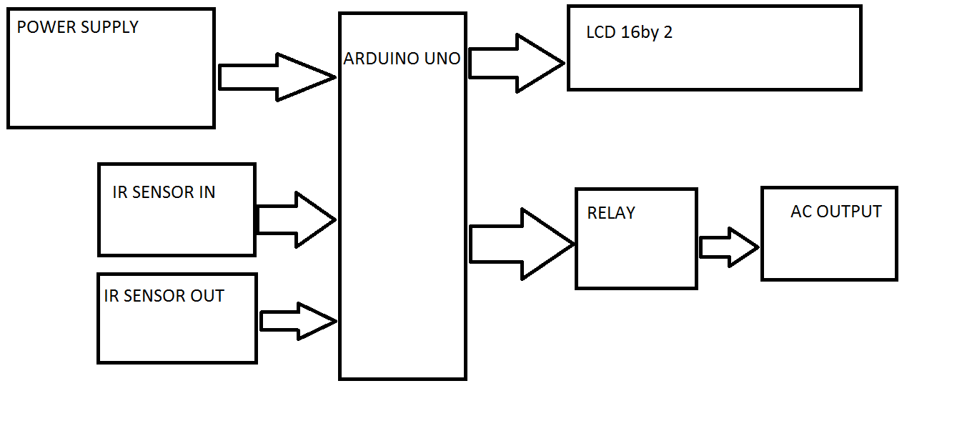

**3.2 Circuit Diagram**

A circuit diagram provides a visual representation of the electrical components and their interconnections in the IoT-Based In and Out Counting System. It illustrates how the components such as sensors, microcontroller, LED lights, digital display, and power supply are connected, aiding in both implementation and troubleshooting.

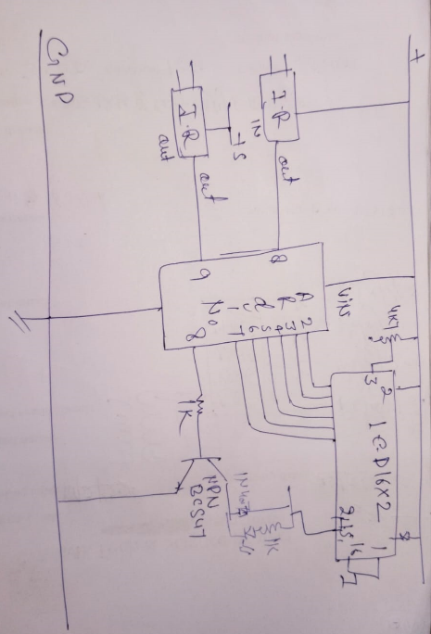

**Chapter 4**

**Components and Coding**

**4.1 Components**

1. Sensors

2. Microcontroller (Arduino Board)

3. LED Lights

4. Digital Display

5. Power Supply

6. Wires and Connectors

7. Embedded Firmware

**4.1.1 Sensors**

Purpose: Detect the movement of individuals entering or exiting the room.

* Types of Sensors:
  + Infrared (IR) Sensors: These sensors detect motion based on the interruption of infrared beams. IR sensors are simple, cost-effective, and ideal for short-range detection, making them suitable for entry/exit monitoring.
* Placement: One sensor is positioned at the entry and another at the exit to track the inflow and outflow of people.

Key Features:

* Quick response time.
* High accuracy for detecting motion.
* Reliable in varying room conditions.

**4.1.2 Microcontroller (Arduino Board)**

Purpose: The brain of the system; processes the input data from sensors and controls the output to LED lights, the digital display, and IoT functionalities.

* Arduino Board (e.g., Arduino Uno): A widely used microcontroller with sufficient GPIO pins to connect the sensors, LED indicators, and a display. It is programmed using Arduino IDE for handling input and output signals.
* Functions:
  + Receives data from the sensors.
  + Processes entry and exit events (increment or decrement the count).
  + Sends real-time updates to the display and IoT cloud platform, if connected.
  + 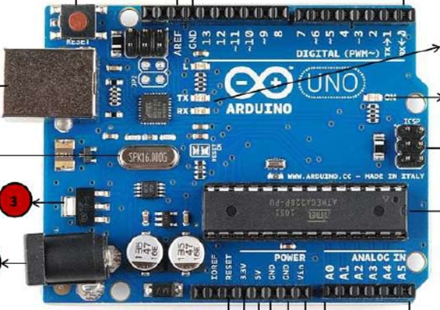Handles error conditions, such as simultaneous triggers from entry and exit sensors.

Key Features:

* Open-source platform with extensive community support.
* Programmable with simple C/C++-based language.
* Suitable for small-scale IoT applications.

**4.1.3 LED Lights**

Purpose: Provide visual feedback to indicate an entry or exit event.

* Description:
  + A standard Light Emitting Diode (LED) is used.
  + Connected to the microcontroller via output pins.
  + LED lights blink when the entry or exit sensor is triggered.
* Significance:
  + Offers real-time feedback to users or facility managers.
  + Enhances user experience by visually confirming detection events.

Key Features:

* Low power consumption.
* Immediate response to sensor triggers.
* Easy to integrate with the microcontroller.

**4.1.4 Digital Display**

Purpose: Shows the real-time count of individuals inside the room.

* Display Type:
  + 7-Segment Display: A simple and cost-effective option to display numeric values (occupancy count).
  + LCD (Liquid Crystal Display): For more detailed information, like additional system status messages or alerts.
* Connection: The display is interfaced with the microcontroller using protocols such as I2C (Inter-Integrated Circuit) or SPI (Serial Peripheral Interface).
* Significance:
  + Ensures the count is easily visible and understandable.
  + Provides immediate insight into occupancy levels for users on-site.

Key Features:

* Compact design with low power requirements.
* Real-time updates for seamless monitoring.
* Expandable options for customization (e.g., adding messages or alerts).

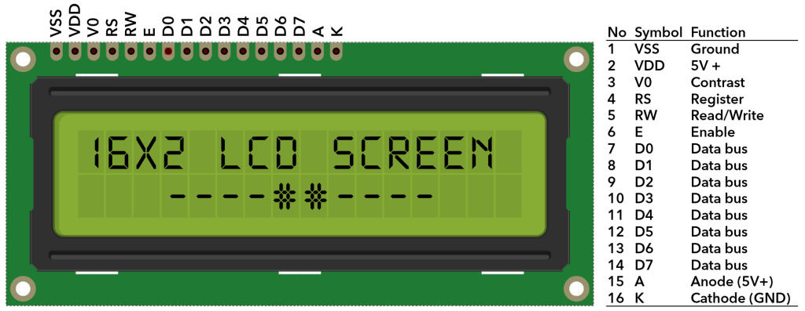

**4.1.5 Power Supply**

Purpose: Provides consistent and reliable power to the system components.

* Description:
  + AC-DC Adapter: For installations requiring constant power, the system can be connected to an electrical outlet using a 5V or 12V adapter, depending on the components used.
  + Battery Backup: Portable installations may use rechargeable batteries for power autonomy.
* Power Regulation:
  + Voltage regulators (e.g., 7805) ensure that all components receive the required voltage.
  + Grounding and decoupling capacitors are used to stabilize the power supply and eliminate noise.

Key Features:

* Ensures uninterrupted operation.
* Scalable for portable or fixed setups.
* Protects sensitive components from power surges.

**4.1.6 Wires and Connectors**

Purpose: Facilitate connections between sensors, microcontroller, LEDs, and other components.

* Description:
  + Jumper Wires: Used for breadboard prototyping and quick connections during development.
  + Soldered Connections: Used in final builds for secure and reliable connections.
* Significance:
  + Ensures signal integrity and minimizes data loss.
  + Provides flexibility during prototyping and testing phases.

**4.1.7 Embedded Firmware**

Purpose: Acts as the software backbone to control hardware components.

* Arduino IDE:
  + Provides a simple programming environment for coding the logic of the system.
  + Implements features such as error handling, real-time counting, and cloud communication.
* Functions:
  + Processes signals from sensors and updates the display.
  + Implements debounce logic to avoid false triggers.
  + Connects with IoT platforms for remote data access.

**4.2 Coding**

#include<LiquidCrystal.h>

LiquidCrystal lcd(13,12,5,4,3,2);

#define in 10

#define out 8

#define relay 9

int count=0;

void IN()

{

count++;

lcd.clear();

lcd.print("Person In Room:");

lcd.setCursor(0,1);

lcd.print(count);

delay(1000);

}

void OUT()

{

count--;

lcd.clear();

lcd.print("Person In Room:");

lcd.setCursor(0,1);

delay(1000);

}

void setup()

{

lcd.begin(16,2);

lcd.print("Visitor Counter");

delay(2000);

pinMode(in, INPUT);

pinMode(out, INPUT);

pinMode(relay, OUTPU

lcd.print("Person In Room:");

lcd.setCursor(0,1);

lcd.print(count);

}

void loop()

{

if(digitalRead(in))

IN();

if(digitalRead(out))

OUT();

if(count<=0)

{

digitalWrite(relay, LOW);

lcd.clear();

lcd.print("Nobody In Room");

lcd.setCursor(0,1);

lcd.print("Light Is Off");

delay(200);

}

else

digitalWrite(relay, HIGH);

}

**Chapter 5**

**System Testing**

**Introduction:**

Software testing is an investigation conducted to provide stakeholders with information about the quality of the product or service under test. Software testing can also provide an objective, independent view of the software to allow the business to appreciate and understand the risks of software implementation. Test techniques include, but are not limited to the process of executing a program or application with the intent of finding software bugs (errors or other defects). Software testing can be stated as the process of validating and verifying that a computer program/application/product:

* Meets the requirements that guided its design and development,
* Works as expected,
* Can be implemented with the same characteristics, and satisfies the needs of stakeholders.

Testing can never completely identify all the defects within software. Instead, it furnishes a criticism or comparison that compares the state and behavior of the product against oracles—principles or mechanisms by which someone might recognize a problem. These oracles may include (but are not limited to) specifications, contracts, comparable products, past versions of the same product, inferences about intended or expected purpose, user or customer expectations, relevant standards, applicable laws, or other criteria. A very fundamental problem with software testing is that testing under all combinations of inputs and preconditions (initial state) is not feasible, even with a simple product. This means that the number of defects in a software product can be very large and defects that occur infrequently are difficult to find in testing. More significantly, non-functional dimensions of quality (how it is supposed to be versus what it is supposed to do)— usability, scalability, performance, compatibility, reliability—can be highly subjective; something that constitutes sufficient value to one person may be intolerable to another.

**5.1 FUNCTIONAL TESTING**

In software development, functional testing is a type of software testing that validates the software system against the functional requirements/specifications. The purpose of functional testing is to ensure that the system performs and behaves as expected under given conditions. It primarily focuses on testing the functionality of the software application by providing appropriate input and verifying the output against the expected results.

**Characteristics of Functional Testing**

It verifies that the application performs as intended based on the defined functional requirements. It does not concern itself with the underlying code structure.

* It ensures that each function of the software application works in accordance with the requirement specification.
* It is typically conducted manually or using automated testing tools.

**Functional Testing Process**

1. Requirement Analysis: Identify and understand the functional requirements of the system.

2. Test Case Design: Develop test cases that outline input data, execution steps, and expected outcomes.

3. Test Execution: Run the designed test cases and document the results.

4. Defect Reporting: Log and track any defects or inconsistencies found during testing.

5. Retesting and Regression Testing: Verify fixed defects and ensure new changes have not introduced additional issues.

**Types of Functional Testing**

Functional testing includes various subtypes, such as:

* Smoke Testing: A preliminary test to check the basic functionality of the software.
* Sanity Testing: A quick, focused test to validate specific functionalities after minor changes.
* Regression Testing: Ensuring new code changes do not negatively impact existing functionalities.
* User Acceptance Testing (UAT): Validating the software from an end-user perspective before deployment.
* Integration Testing: Testing the interfaces and interactions between integrated components or systems.

**Benefits of Functional Testing**

• Ensures that the software meets business and user requirements.

• Identifies defects early in the development cycle.

• Improves software quality and reliability.

• Provides confidence in the product before its release.

Functional testing is an essential part of the software testing lifecycle, ensuring that an application meets its intended functional requirements. By systematically verifying the expected behavior of software, functional testing contributes to building robust, error-free, and high quality applications that align with business needs.

**5.2 Performance Testing**

* Response Time Testing: Assessing the system’s ability to update the count in real-time when people enter or exit the room.
* Load Testing: Evaluating the system's performance under varying numbers of entries and exits to ensure it handles high traffic efficiently.

**5.3 Accuracy Testing**

* Sensor Accuracy Testing: Ensuring that the sensors accurately detect entry and exit movements without false positives or negatives.
* Counting Accuracy Testing: Verifying that the displayed count matches the actual number of people in the room.

**5.4 Usability Testing**

* User Interface Testing: Assessing the ease of use of the web/mobile application and the readability of the digital display.
* User Experience Testing: Gathering feedback from users (e.g., facility managers, event organizers) to ensure the system meets their needs and expectations.

**5.5 Environmental Testing**

* Temperature and Humidity Testing: Ensuring the system operates reliably under different environmental conditions.
* Dust and Water Resistance Testing: Verifying that the sensors and other components are resistant to dust and minor water exposure.

**5.6 Reliability Testing**

* Continuous Operation Testing: Running the system for extended periods to ensure it performs consistently over time.
* Failure Mode Testing: Simulating potential failures (e.g., power loss, sensor malfunction) to ensure the system can recover gracefully.

**5.7 Security Testing**

* Data Security Testing: Ensuring that the data transmitted to the cloud is secure and protected from unauthorized access.
* Access Control Testing: Verifying that only authorized users can access and control the system via the web/mobile application.

**5.10 User Interface Testing**

Not applicable

**5.11 Navigation Testing**

Not applicable

**5.12 Form testing:-**

Not applicable

**Chapter 6**

**Scope of Improvement**

The IoT-Based In and Out Counting System is designed to monitor and count the number of individuals entering and exiting a specific room or area. While the current implementation meets the basic requirements, there are several areas where improvements can be made to enhance functionality, scalability, and user experience. Here are some potential areas for improvement:

1.Sensor Technology Enhancement

* Upgrade to Advanced Sensors: Incorporate more sophisticated sensors, such as LiDAR or stereoscopic cameras, to improve accuracy in counting, especially in high-traffic environments.
* Thermal Imaging Sensors: Utilize thermal sensors to detect heat signatures, which can be effective in low-light conditions or to differentiate between humans and objects.

2. Machine Learning Integration

* Predictive Analytics: Implement machine learning algorithms to predict occupancy trends based on historical data, aiding in resource planning and management.
* Anomaly Detection: Use AI to detect unusual patterns, such as unexpected surges in occupancy, which could indicate security issues or emergency situations.

3. Scalability Enhancements

* Modular Architecture: Redesign the system architecture to be modular, allowing for easy addition of more sensors and devices to cover larger areas or multiple rooms.
* Edge Computing: Introduce edge computing capabilities to process data locally, reducing latency and reliance on cloud services for real-time operations.

4. Enhanced Connectivity Options

* Bluetooth Low Energy (BLE): Incorporate BLE for low-power wireless communication, which can be useful for battery-operated deployments.
* LoRaWAN Integration: Use Long Range Wide Area Network (LoRaWAN) technology for communication over longer distances with low power consumption, suitable for large facilities.

5. User Interface Improvements

* Customizable Dashboards: Offer users the ability to customize their dashboards on the web/mobile application to display relevant data and analytics.
* Multi-Language Support: Include support for multiple languages to cater to a broader user base.

6. Energy Efficiency

* Power Management: Implement smart power management techniques, such as sleep modes for sensors when no activity is detected, to reduce energy consumption.
* Renewable Energy Sources: Explore options for powering the system using renewable energy sources like solar panels, especially for outdoor or remote installations.

**Use Case**

**1. Hospitals and Clinics**

Use Case

* Patient Flow Management in Outpatient Departments (OPD): In hospitals, managing patient flow is critical to avoid overcrowding in waiting areas, ensure smooth operations, and allocate resources efficiently. The system can monitor the number of patients entering and exiting the OPD in real time, providing accurate data for staff to manage queues and prioritize care.

Benefits

* Prevents overcrowding in sensitive medical environments.
* Helps allocate staff and resources effectively based on patient volume.
* Allows hospital management to maintain compliance with health and safety standards, especially during pandemics or health crises.

Scenario Example

In a busy OPD, the IoT-based system updates the real-time patient count on a digital display for staff and patients. If the maximum capacity is reached, an alert can notify hospital staff to limit entry or reroute patients to other departments.

**2. Auditoriums and Event Venues**

Use Case

* Occupancy Monitoring for Crowd Control: In auditoriums or event venues, tracking the number of attendees is crucial to prevent overcrowding, maintain safety standards, and comply with legal capacity limits. The system can count individuals entering and exiting the venue, ensuring that occupancy stays within safe limits.

Benefits

* Ensures compliance with fire and safety regulations by monitoring the maximum capacity.
* Enhances the experience of attendees by avoiding overcrowded seating areas.
* Real-time data helps organizers make informed decisions, such as allowing additional entries or closing access temporarily.

Scenario Example

During a conference in an auditorium, the system detects that the venue is nearing its capacity. The display outside the auditorium shows a "Full" message to prevent further entries, while alerts are sent to the event organizers for action.

**3. Offices and Corporate Spaces**

Use Case

* Space Utilization Monitoring: In modern corporate offices, ensuring efficient use of shared spaces like meeting rooms, training halls, and cafeterias is essential. The system can track the number of employees entering and exiting these spaces, helping managers optimize their use.

Benefits

* Helps in optimizing meeting room bookings and reduces scheduling conflicts.
* Provides data for space utilization analysis, helping to redesign office layouts if necessary.
* Enhances employee experience by ensuring rooms are neither overbooked nor underutilized.

Scenario Example

The system monitors the occupancy of a conference room. If the room reaches its capacity, the HR team can suggest using an alternative room. Historical data gathered by the system also helps plan space requirements for future office expansions.

**4. Libraries and Study Areas**

Use Case

* Seating Availability for Patrons: Libraries and study areas often experience uneven usage, with certain areas becoming overcrowded while others remain empty. The system tracks occupancy in different zones of the library, providing students and staff with live data on available seating.

Benefits

* Reduces the frustration of students looking for seats during peak hours.
* Allows library staff to manage space allocation more effectively.
* Ensures compliance with safety standards during exams or busy periods.

Scenario Example

At a university library, students can view real-time seating availability on a mobile app connected to the system, helping them find a suitable spot without unnecessary waiting.

**Conclusion**

The IoT-Based In and Out Counting System offers a practical and efficient solution for real-time occupancy monitoring. By automating the counting process with sensors and providing immediate visual feedback through LED indicators and a digital display, the system enhances the management of spaces where knowing the exact number of occupants is essential.

This project demonstrates how combining simple components like sensors, LED lights, and an Arduino board can create a powerful tool with significant real-world applications. It not only improves operational efficiency but also contributes to safety and compliance with regulations in various settings.

Moving forward, there's potential to expand the system's capabilities:

* Remote Monitoring: Integrating network connectivity to allow remote access to occupancy data via smartphones or computers.
* Data Logging: Recording occupancy over time to analyze patterns, peak usage times, and optimize resource allocation.
* Alerts and Notifications: Setting up thresholds to alert management when occupancy reaches a certain level.
* Scalability: Adapting the system for larger venues by adding more sensors or integrating with existing security infrastructure.

In essence, the IoT-Based In and Out Counting System is more than just a project—it's a stepping stone toward smarter facility management. By embracing this technology, organizations can enhance efficiency, improve safety, and make data-driven decisions that positively impact their operations.